Student Name:…………………………………………………...

Student ID:………………………………………………………..

**Quiz 5: Review**

1. Given a list of items in table 1, take items using your list iteration procedure.

Insert all items into the hash table of size 27 by using the linear probing algorithm to solve collisions

We use hash function: x % 27:

| **0** | **1** | **2** | **3** | **4** | **5** | **6** | **7** | **8** | **9** | **10** | **11** | **12** | **13** | **14** | **15** |
| --- | --- | --- | --- | --- | --- | --- | --- | --- | --- | --- | --- | --- | --- | --- | --- |
| 45 | 30 | 80 | 20 | 35 | 70 | 90 | 25 | 21 | 39 | 37 | 38 | 75 | 78 | 76 | 90 |

**Table 1: Items**

2. Graph — Shortest path algorithm

Run the Dijkstra's algorithm on the graph Fig. 1 from your startinq node, and fill the following table with corresponding values after each step of the algorithm

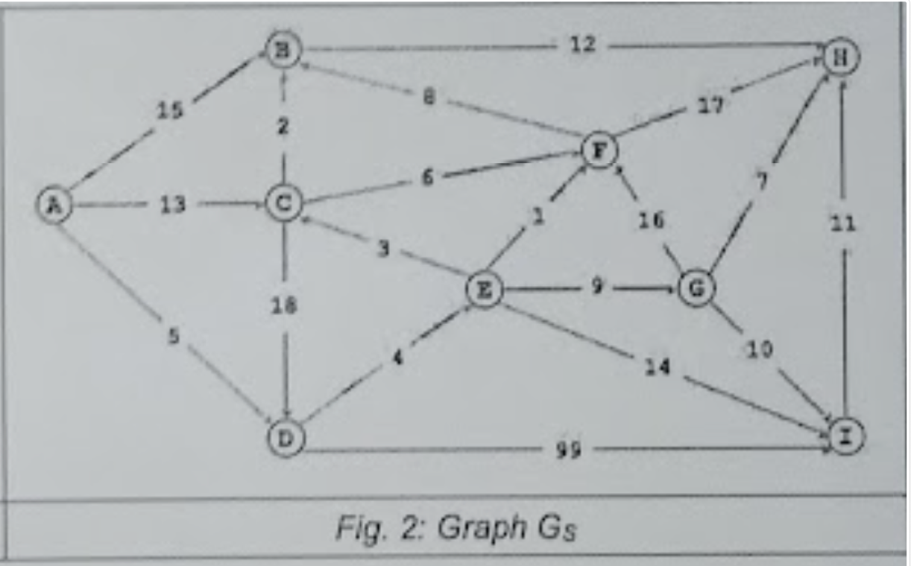

**Fig 1: Graph**

**[4, D]**

| **Selected Nodes** | **A** | **B** | **C** | **D** | **E** | **F** | **G** | **H** | **I** |
| --- | --- | --- | --- | --- | --- | --- | --- | --- | --- |
|  |  |  |  | **0** |  |  |  |  |  |
| **D** |  |  |  | **-** | **4** |  |  |  | **99** |
| **D, E** |  |  | **7** | **-** | **-** | **5** | **13** |  | **18** |
| **D, E, F** |  |  | **7** | **-** | **-** | **-** | **13** | **22** | **18** |
| **D, E, F, C** |  | **9** | **-** | **-** | **-** | **-** | **13** | **22** | **18** |
| **D, E, F, C, B** |  | **-** | **-** | **-** | **-** | **-** | **13** | **21** | **18** |
| **D, E, F, C, B, G** |  | **-** | **-** | **-** | **-** | **-** | **-** | **20** | **18** |
| **D, E, F, C, B, G, I** |  | **-** | **-** | **-** | **-** | **-** | **-** | **20** | **-** |
| **D, E, F, C, B, G, I, H** |  | **-** | **-** | **-** | **-** | **-** | **-** | **-** | **-** |

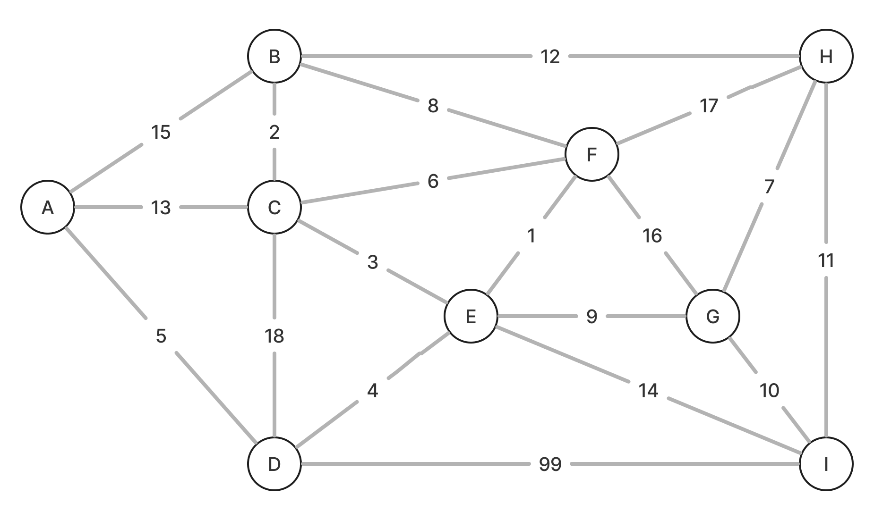

D -> E -> F -> C -> B -> G -> I -> H